Use of coaching
Intent:
*to support the development of teaching and learning across the Trust
*to further develop the expertise and effectiveness of Subject and Senior Leads using coaching as a leadership tool and deliberate act, to monitor and support staff development and teaching and learning
*that Subject Leaders have theory/evidence based expertise through coaching and operationally focussed implementation
*to support implementation of PPDR process
*to link to Trust learning characteristics to support staff development, especially in relation to the personal and creative development area.
*to provide a unity of approach with common understanding, language and aims
*to acknowledge professional and personal development of colleagues and ourselves as a continuous process and not just an event
*to embed a culture and ethos in our settings conducive to positive coaching experiences, with elements such as:
- interacting with respect
- having an open door policy where drop ins and feedback are the norm
- staff are motivated self- improvers who reflect on their own practice and are solution focussed
- not avoiding challenge
- observing and highlighting ongoing positives specifically and publicly
*to respond to aspects of our staff wellbeing survey such as; regularity of feedback and having opportunities to develop across the Trust

COACHING APPROACHES

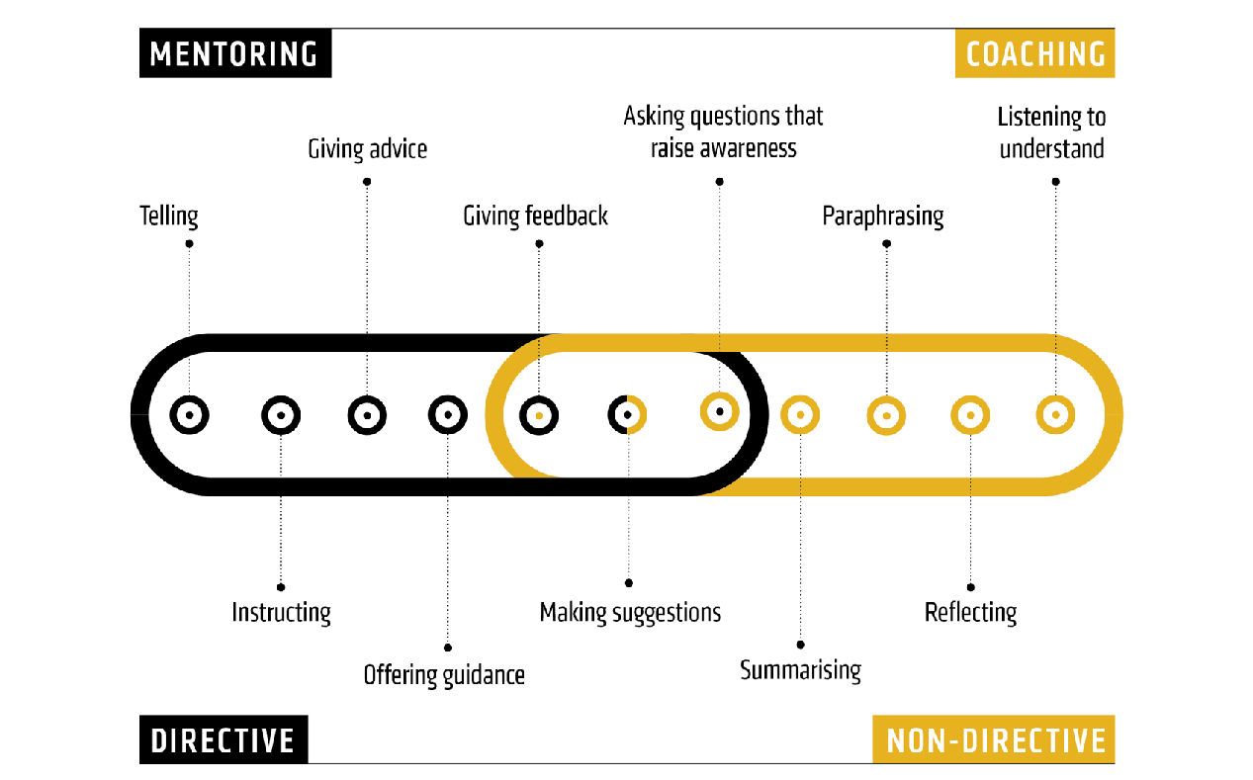
‘See it, name it, do it’ (IC instructional coaching) BASIC (non directive) coaching
*less time discussing *active listening
*more time enacting, rehearsing *powerful questions
*responding to bespoke feedback * designing goals and actions
ASSISTANT ACADEMY HEADS – need to be familiar with both methods. BASIC for PDR and IC for subject leadership.
SUBJECT LEADS – subject specific development and AHs when appropriate eg: performance related
ACADEMY HEADS – through PDR process and general staff development. May need IC in some instances.
It should be noted that, although the above are the general areas of coaching that colleagues will need to use, at any point within a professional conversation, they may need to use different coaching approaches, depending on colleagues’ experience, expertise or confidence.

Impact of successful implementation
- improving teaching and learning in classrooms
- learning characteristics to be a focus for staff development and used as one of the vehicles for improvement
- colleagues report feeling increasingly valued
- open working relationships and an ethos of positivity and support in place
- views aired and supported
- new support alliances formed across hubs, the wider Trust and externally
- an effective PPDR process in place which supports present and future development rather than evaluating what has already gone.
- Colleagues playing an active role in their own development
- Colleagues feeling a stronger connection to Trust community and sense of belonging
- CPD being understood and valued as continuous learning

