
Consortium Trust
External
Pool Booking Form

Location: Yoxford & Peasenhall Primary School

Name:
Email address:
Number of people attending pool: (min: 2 max: 24)
Date(s):
Time(s):
Reason for pool use:
£

- You will be invoiced prior to your booked session at the rate of £40ph
- You must read, sign and return the pool terms and conditions below, before using the pool
- Access information will be sent over once payment has been made

High St, Yoxford, Saxmundham IP17 3EU
Entrance small gate
Tall gates
Pool entrance
Roadside parking

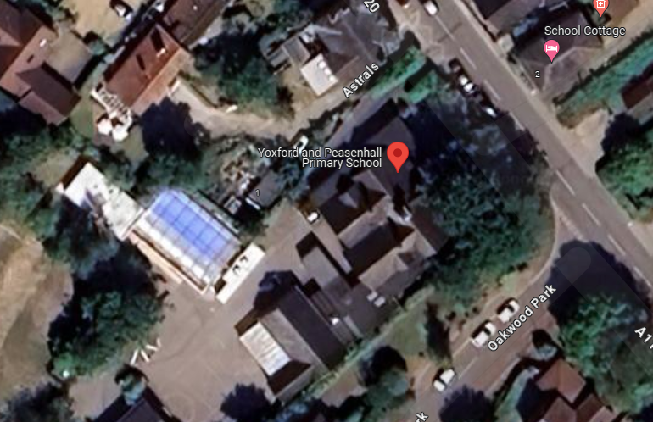


Yoxford and Peasenhall Pool Terms and Conditions
We hope that you will enjoy using the pool as if it were your own. To ensure that everyone is happy with the privacy, security and safety the following rules MUST be observed.

- Health and Safety
  - There is no lifeguard on duty at any time therefore it is imperative that the hirer takes all steps necessary to ensure the safety of himself/herself and guests. All swimmers enter the pool and pool complex at their own risk.
  - A minimum of 2 people to use the pool at any one time, no lone swimming.
  - There must be no more than 24 people using the pool at any one time.
  - All swimmers (or their guardians) must deem themselves to be well enough and physically fit enough to swim.
  - There must be an adult onsite in the pool area at all times when the pool is in use.
  - Care should be taken that food or drink is not consumed immediately before swimming as personal accidents may result.
  - Observe the signs in the pool complex at all times. It is for your safety.

- Hygiene
  - No footwear allowed beyond the entrance mat.
  - Swimmers must shower before entering the pool as this reduces the need for chemicals in the pool.
  - Do not use talcum powder in the Pool Complex.
  - Young children still using nappies MUST wear appropriate swimwear, for example, aqua nappies, and you must take all used nappies home.
  - Please ensure no animals enter the pool complex.

- Pool
  - No running, bombing, diving or jumping in in any part of the pool.
  - No smoking in the pool complex.
  - No eating or drinking in the pool complex.
  - No glass to be taken into the pool complex.
  - No submarine diving or scuba gear to be used in the pool.

- Emergencies
  - The throw rope is for emergency use only.
  - Please ensure all exits and fire exits are kept clear at all times.

- Access and Parking
  - Access to the pool is via Yoxford Primary School.
  - There is no car parking available on site.

- Housekeeping
  - Please ensure all doors and windows remain closed at all times, as this maintains the important temperature balance within the pool complex.
  - Please ensure that you keep to your allotted session. There is a clock in the pool area.
  - Please note that the changing room will be available to you for the duration of your booking.
  - Swimmers must use the mop and buckets provided to mop up any excess water in the changing rooms.
  - Please leave the pool complex as you have found it and would like to find it.
  - Consortium Trust accept no liability for personal items left behind, or for damage or theft of personal possessions while using the pool facility.

- Damage
  - Please notify Robin Chew, Head of Services Facilities of any damage to the pool, pool complex or equipment by email r.chew@consortiumtrust.org.uk

I confirm I have read the terms and conditions of the pool rules:
Date:
Print name:

